Install Git:
Windows: $ git bash : https://gitforwindows.org/
Ubuntu: $ sudo apt-get install git-core
RedHat: $ sudo yum install git-core
Git Config:
Set a Git username:
$ git config --global user.name "sansaraf"
$ git config --global user.email "sanjay@gmail.com"
$ git config --list

Need HELP?
Open the help page in browser or in console
$ git help <verb>
$ git help pull

Initialize a repository from existing code.
$ mkdir LearnGit
$ cd LearnGit
$ git init # another way to initialize is use git clone <remote_path>
$ touch .project
$ git status (will show the untracked file before git commit)
$ touch .gitignore (to block some files in repo to not get commited to remote repo)
$ vi .gitignore (and add the files to be ignored)
.project
*.pyc
$ git status (will not show the files included in .gitignore)

Basic WorkFlow
Working Dir Staging Area .git Dir(Repo)
| | |
|<---------------------Checkout the Project-----------------------|
| | |
|---------------Stage Fixes---------->| |
| | |
| |------------Commit------->|
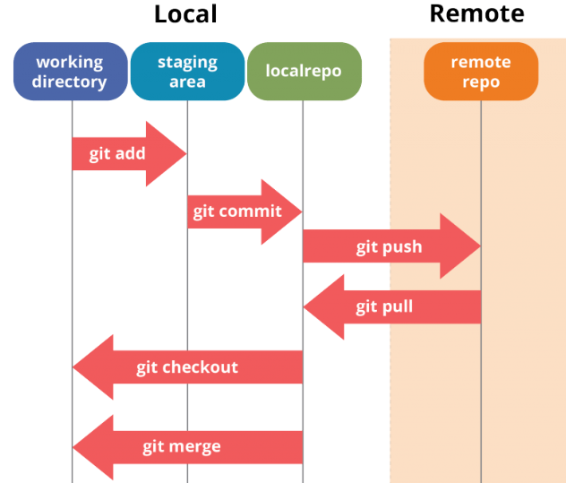

⇨ Add a file to staging area
$ git add .gitignore
$ git add myfile.py
$ git status
⇨ Remove the file from staging Area
$ git reset myfile.py (bring back myfile.py to untracked stage)
$ git reset (will bring all staged file to untracked)

Our First Commit
$ git add -A (add All file to staging area including parent directory)
$ git add –all (add All file to staging area including parent directory)
$ git add . (only current dir will be added )
$ git add * (only current dir will be added )
$ git add myfile.py

$ git commit -m "Initial Commit"
$ git status
$ git log

Cloning a Remote Repo
$ cd RemoteRepo
$ git clone git@github.com:sansaraf/MyScripts.git .
If you get error then you may have to generate key and integrate with Github.com
$ ssh-keygen -t rsa

View remote origin
$ git remote -v
Set remote origin (If $ git remote -v if blank)
$ git remote add origin git@github.com:sansaraf/sanjay-new-repo.git

Change remote origin (change remote repository)
$ git remote set-url origin git@github.com:sansaraf/sanjay-new-repo.git

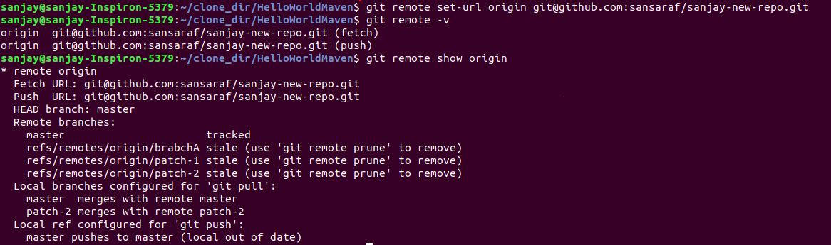

Git Branching

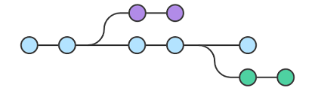

To view list branches
$ git branch # List all branches
$ git branch –a # List all remote+local branches
$ git branch -r # List remote branches

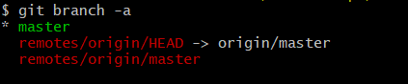

Create a Branch
$ $ git branch <branch>
Create a Branch and checkout simultaneously
$ $ git checkout -b <branch>

Pull master branch changes in a different branch
$ git checkout <branch>
$ git merge master
Deleting a branch
$ git branch -d <branch>
$ git branch -D <branch> # Forcefully
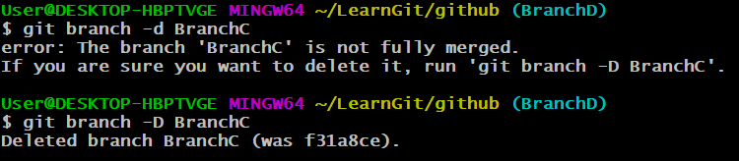
Rename a branch
$ git branch -m <new_branch_name>

checkout to remote branch

Each remote repository will contain its own set of branches. In order to checkout a remote branch you have to first fetch the contents of the branch.
$ git fetch --all
$ git checkout <remote_branch>

Git diff command
Diffing is a function that takes two input data sets and outputs the changes between them. Git diff can be used on file, commits, branches
$ git diff
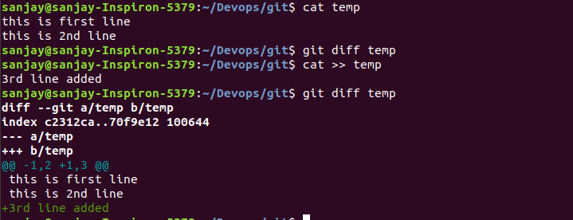

Git push (pushing the changes to remote)
git push is most commonly used to publish an upload local changes to a central repository. After a local repository has been modified a push is executed to share the modifications with remote team members.
$ git pull origin master
Note- we should always pull first then push when there is parallel development is going on
$ git push origin master # Push the specified branch to <remote>

$ git push origin master --force
Sometime you may get below error then you have to -force the push but this is not commanded. Usually the error is caused by another user pushing to the same branch. You can remedy this by fetching and merging the remote branch, or using pull to perform both at once.
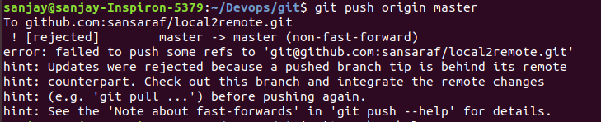

Push all of your local branches to the specified remote.
$ git push origin --all
Tags are not automatically pushed when you push a branch or use the --all option.
$ git push origin master --tags

Git pull (pulling changes from remote)
The git pull command first runs git fetch which downloads content from the specified remote repository. Then a git merge is executed to merge the remote content refs and heads into a new local merge commit. To better demonstrate the pull and merging process let us consider the following example. Assume we have a repository with a master branch and a remote origin.
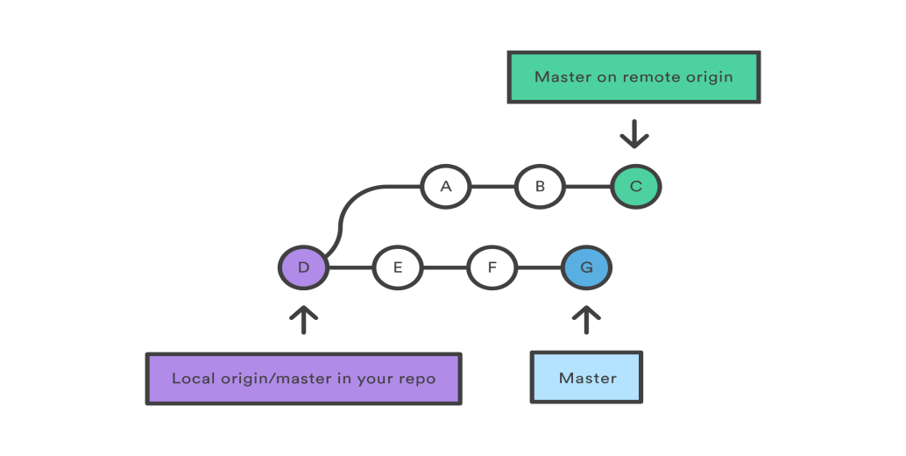
In this scenario, git pull will download all the changes from the point where the local and master diverged. In this example, that point is E. git pull will fetch the diverged remote commits which are A-B-C. The pull process will then create a new local merge commit containing the content of the new diverged remote commits.
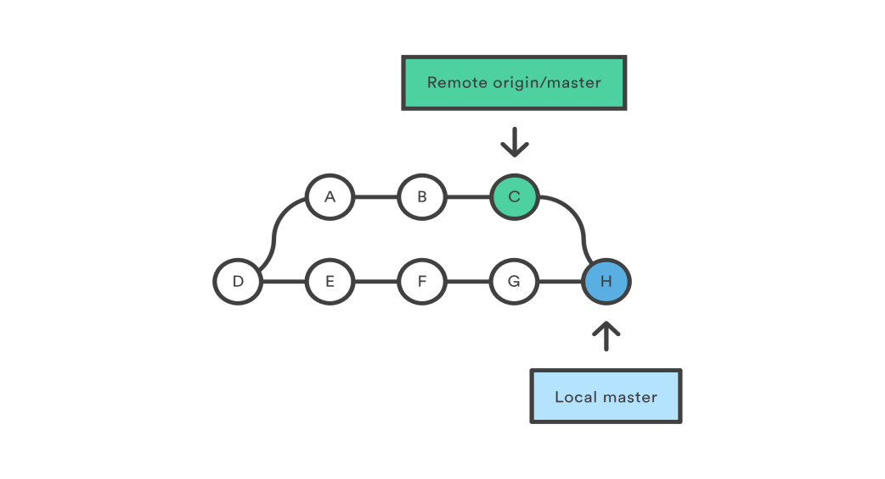
In the above diagram, we can see the new commit H. This commit is a new merge commit that contains the contents of remote A-B-C commits and has a combined log message.

Pull Request
Pull requests are a feature that makes it easier for developers to collaborate. In simplest form, pull requests are a mechanism for a developer to notify team members that they have completed a feature. Once their feature branch is ready, the developer files a pull request via their account. This lets everybody involved know that they need to review the code and merge it into the master branch.
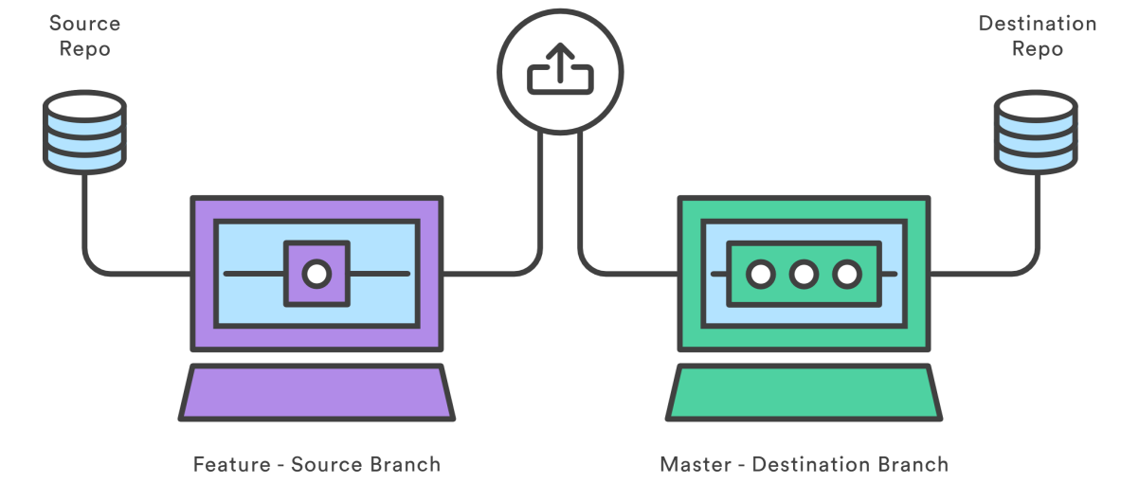

Git Fetch
The git fetch command downloads commits, files, and refs from a remote repository into your local repo

Fetches all of the branches from the repository. This also downloads all of the required commits and files from the other repository.
$ git fetch <remote>
fetch the specified branch.
$ git fetch origin master

Note- Remote changes will not be visible after git fetch unless you complete git merge
$ git merger origin/master

Git Pull = Git Fetch + Git Merge (git pull does a git fetch followed by a git merge)
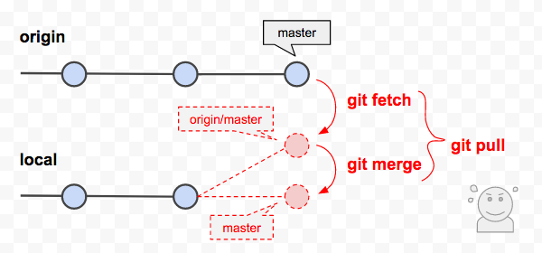

Git merge
Git merge is used to combine two branches.
Say we have a new branch feature that is based off the master branch. We now want to merge this feature branch into master.
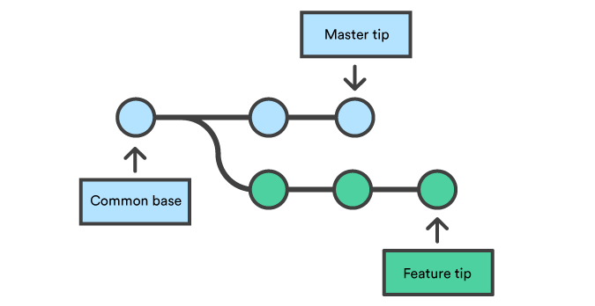
Invoking this command will merge the specified branch feature into the current branch (assume master).
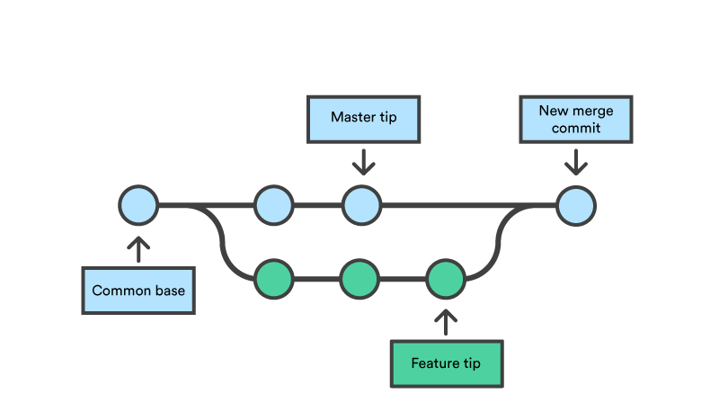
Merge commits are unique against other commits in the fact that they have two parent commits. When creating a merge commit Git will attempt to auto magically merge the separate histories for you. If Git encounters a piece of data that is changed in both histories it will be unable to automatically combine them. This scenario is a version control conflict and Git will need user intervention to continue.
Branch-B
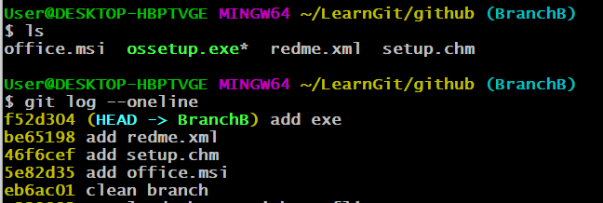
Branch-C
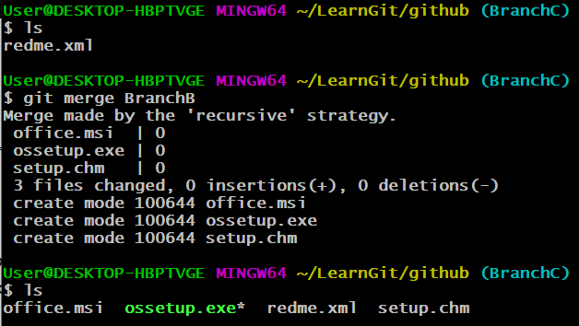

Merge conflict
Version control systems are all about managing contributions between multiple authors. Sometimes multiple developers may try to edit the same content. If Developer A tries to edit code that Developer B is editing a conflict may occur.
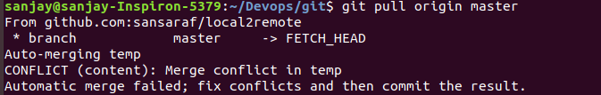
We can see some strange new additions
<<<<<<< HEAD
=======
>>>>>>> new_branch_to_merge_later
The ======= line is the "center" of the conflict. All the content between the center and the <<<<<<< HEAD line is content that exists in the current branch master which the HEAD ref is pointing to. Alternatively all content between the center and >>>>>>> new_branch_to_merge_later is content that is present in our merging branch.

How to resolve merge conflicts?
Step-1 Use any editor and make changes in file.
Step-2 $ git commit -m "merged and resolved the conflict in script.sh"

Git Cherry Picking
Managing feature branch changes that aren't quite ready for a full merge can be a difficult task. Sometimes you don't want to push a whole branch into another, and only need to pick a few specific commits. This process is called cherry-picking.
Cherry picking is commonly discouraged in the developer community. The main reason is that it creates duplicate commits and you lose the ability to track the commit history. You should always aim to use git merge.

Branch-B
Branch-C
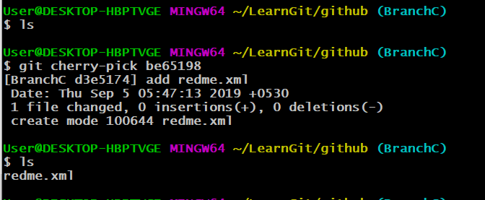
Git stash
The git stash command takes your uncommitted changes, saves them away for later use.
Once you stash your changes, you're free to make changes, create new commits, switch branches, and perform any other Git operations; then come back and re-apply your stash when you're ready.
Note- Note that the stash is local to your Git repository; stashes are not transferred to the server when you push.

Stashing your changes
$$ git stash or
$$ git stash save "Save Branch D changes for now" # stash with message
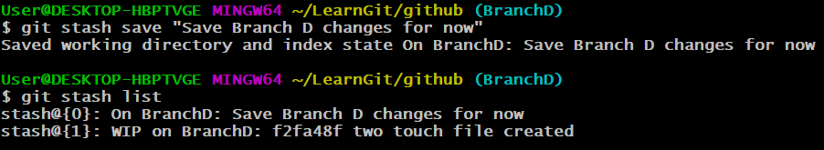

Viewing stash
$$ git stash show
You can reapply previously stashed changes with git stash pop
$$ git stash pop
$$ git stash pop stash@{2} # specific index
Managing multiple stashes
$ git stash list
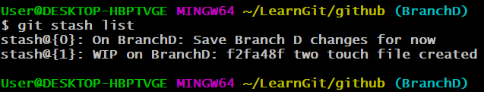

You can choose which stash to re-apply by passing its identifier as the last argument
$$ git stash pop stash@{1}
Cleaning up your stash
$$ git stash drop stash@{1}
Dropped stash@{1} (17e2697fd8251df6163117cb3d58c1f62a5e7cdb)
$$ git stash clear

$ git reflog

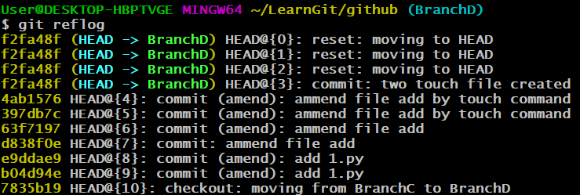
Git HEAD
HEAD is a reference to the last commit in the currently check-out branch.
You can think of the HEAD as the "current branch". When you switch branches with git checkout, the HEAD revision changes to point to the tip of the new branch.
You can see what HEAD points to by doing:
cat .git/HEAD
For example, in my current branch it shows:
$ cat .git/HEAD
ref: refs/heads/master

Git tag
Tags are ref's that point to specific points in Git history. Tagging is generally used to capture a point in history that is used for a marked version release (i.e. v1.0.1). A tag is like a branch that doesn’t change.

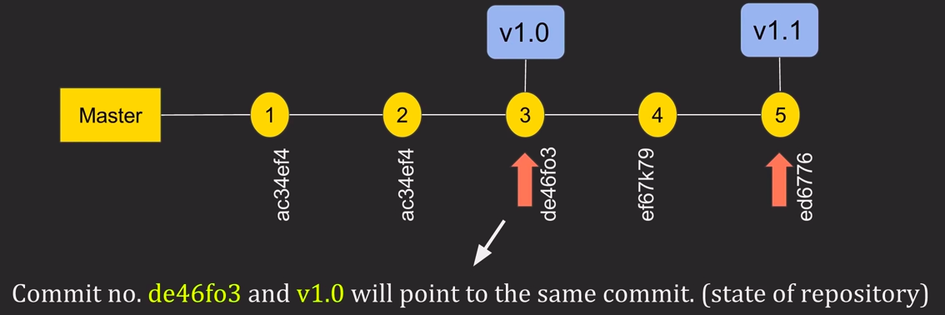

How to create tag
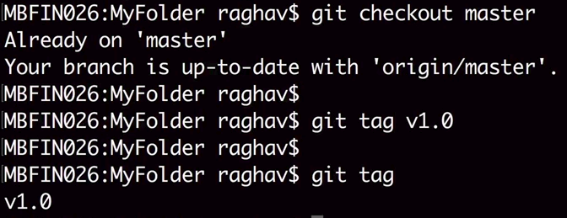
Tag with message
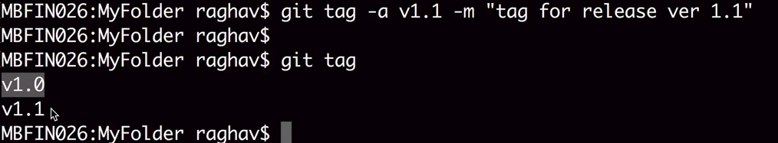

Searching tag
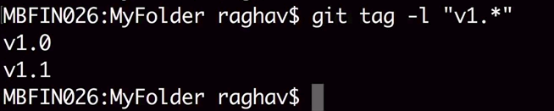
Push tag to remote origin
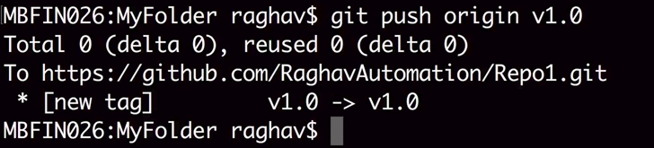
Deleting Tag from local
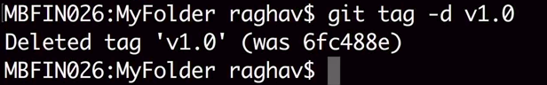
Deleting Tag from remote
$ git push origin -d v1.0

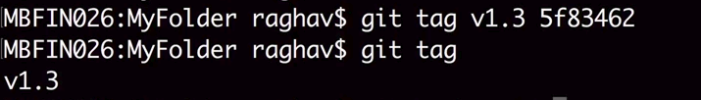
$ git push --tags # push all the tags to remote

Git Tag checkout
You can view the state of a repo at a tag by using the git checkout command.

$ git tag checkout v1
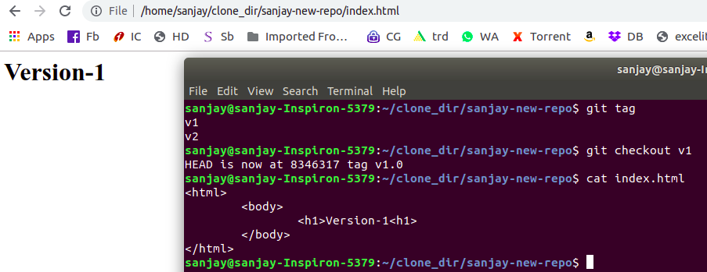
$ git tag checkout v2
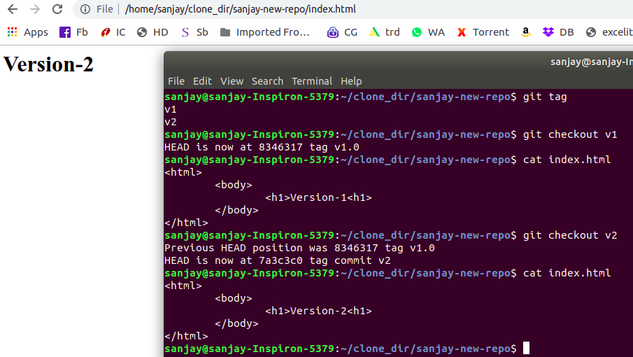

Q. How can I recover a file I deleted in my local repo?

You can get a list of all the deleted files in the working

$$ git ls-files --deleted

If the deletion has not been committed

$ git checkout -- temp.txt # space is needed after –

If the deletion has been committed

$$ git revert 800c680
$$ git status # notice that your changes is reverted to and visible in staging
Or
$$ git checkout 8f04bd7^1 d.py

- How to Rollback to a specific commit ?

$ git checkout 3e580d4

Q. How to rollback from git staging?
$$ git reset
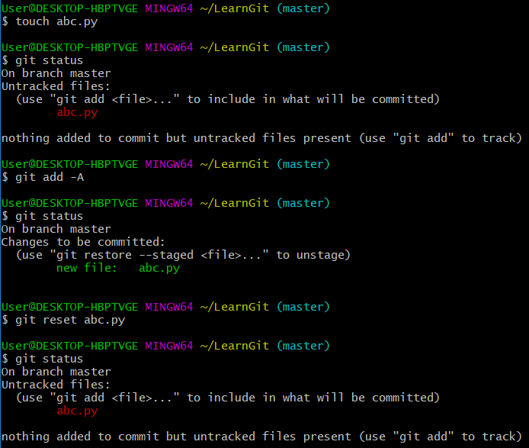

Q. How to come out from git conflict ?
$$ git merge –abort
Q. How to changing the wrong committed messages
$ $ git commit -m “Completed multiply function” (A bad commit with wrong message)
$ $ git commit --amend -m “Completed subtract function” (using –amend to change the message)
$$ git log

Q. How to find which last commit was pushed to origin ?

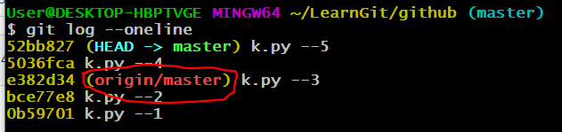

Git Branching strategy

